Self-Service Functionality at StudySearch
Do you have an IRB approved study that is seeking volunteers? StudySearch (SS) is an online, plain language listing of OSU studies that are seeking volunteers. No additional IRB oversight is necessary to list your study. This site regularly gets 2000-5000 visitors/month.
If it is not already listed on StudySearch, someone from your research team can now submit it. Once it is reviewed (and edited by the administrators to meet plain language standards) your study will be listed and available for public viewing.
Remember:
- You will submit the formal title of the study and the SS administrative staff with provide a plain language title that will be seen above the formal title.
- Keep purpose and eligibility in plain language (something similar to your consent forms). Not every eligibility criteria need to be listed.
- Be prepared to upload your most recent consent and IRB approval.
- Key words: put in as many as you can think of that would relate to this study. The site will automatically add the contact person and PI as key words. Our staff will likely add more. Please note: If your department/team has arranged with us a special keyword to be added to your department studies, please add it. (e.g. “HEI” & “Havener” for Havener Eye Institute; “NRI” for Neurological Research Institute)
- Once our staff has reviewed and edited your submission and have it ready for publishing, you will get an email from StudySearch asking you to review it.
- When you have approved it for publication, it will be published and you will be notified.
- Keep track of the number of people who may contact you about your study due to StudySearch.
- Let us know when you no longer need it listed
- Go to StudySearch
- Click on “Submit a Study”
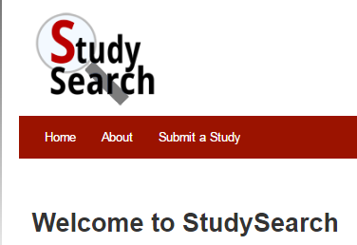
- Log/Sign in with OSU single sign in
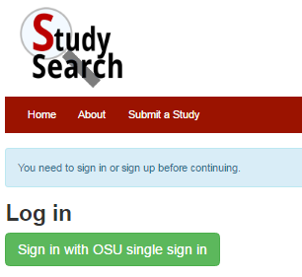
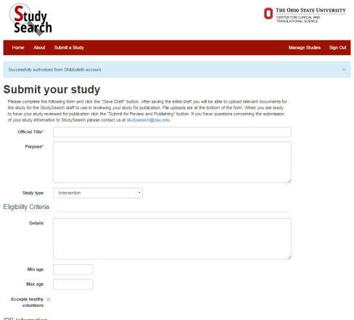
- Complete the form

Mary.Becker@osumc.edu

