MAINTAINING STUDY RECORDS ON CLINICALTRIALS.GOV

All records need to be verified no less than every 12 months, even if nothing has changed. Please follow the instructions below for annual verification.
Records must be updated no later than 30 calendar days of change in enrollment status or any other significant changes to the protocol.
Device Product Not Approved or Cleared by U.S. FDA must be updated no later than 15 calendar days after a change in approval or clearance status has occurred.
Clinical trial results must be posted no later than 1 year after the primary completion date. Delayed results submission is allowed in some cases; please see 42 CFR 11 for more details.
Any errors must be addressed no later than 15 calendar days after notification for clinical trial registration information, or 25 calendar days for clinical trial results information.
Verifying a record for annual maintenance, when no changes need to be made:
- Log in to the ClinicalTrials.gov Protocol Registration and Results System (PRS) website. https://register.clinicaltrials.gov/
Use the organization name and username that you received when your account was generated. For non-cancer clinical trials, the organization will be OhioU. If you do not remember your login information, or if you need to reset your password, contact your administrator.
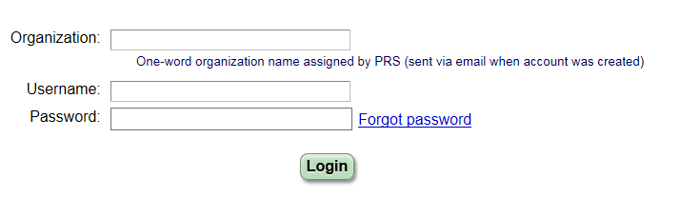
- Click Open next to the record you want to verify.
- Click Open next to Protocol Section.
- Click Edit on the Study Status section.
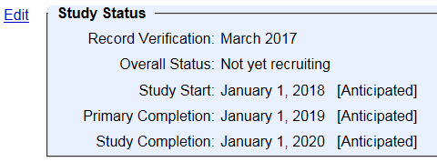
- Update the Record Verification Date to the current month and year.
- Click Save.
- Return to the Record Summary.
- Click Entry Complete in the Next Step box.
- The record owner and responsible party will be sent an automated email to indicate that the record is complete and ready for approval and review.
- The Responsible Party needs to log in to the system to review the record and approve the record by clicking the Approve button within the Next Step box.
- The Responsible Party then needs to release the record for PRS review by clicking the Release button within the Next Step box.
- Once a record is released, it will be sent to the ClinicalTrials.gov PRS quality assurance (QA) review prior to being published to the public site.
If the only change is to update the record verification date and the record did not have any existing problems, you should not receive any review comments from PRS and the record will be made public within 2-5 business days.
Updating a record when changes need to be made:
- Follow steps 1-5 for Verifying a record for annual maintenance.
- Click Edit next to any other sections that need to be updated or Edit All to update the whole record.
- Follow the remaining steps as above.
- If any changes need to be made after an entry is marked complete, click Reset to In-Progress above the Next Step box or simply edit the necessary section and it will automatically reset.
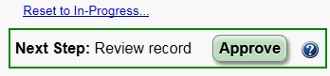
- Once a record is released, it will be sent to the ClinicalTrials.gov PRS QA review prior to being published to the public site.
If there are any comments from the PRS review, the record will be reset to In Progress and the Next Step box will be updated to Address Review Comments. Comments must be addressed no later than 15 calendar days after notification.
A link to the comments will be provided under the PRS Review and there will be a flag by any section(s) that has comments that need to be addressed.
- Repeat steps 2-5 until the PRS review returns no comments. The record will be published to the public site within 2-5 business days.

