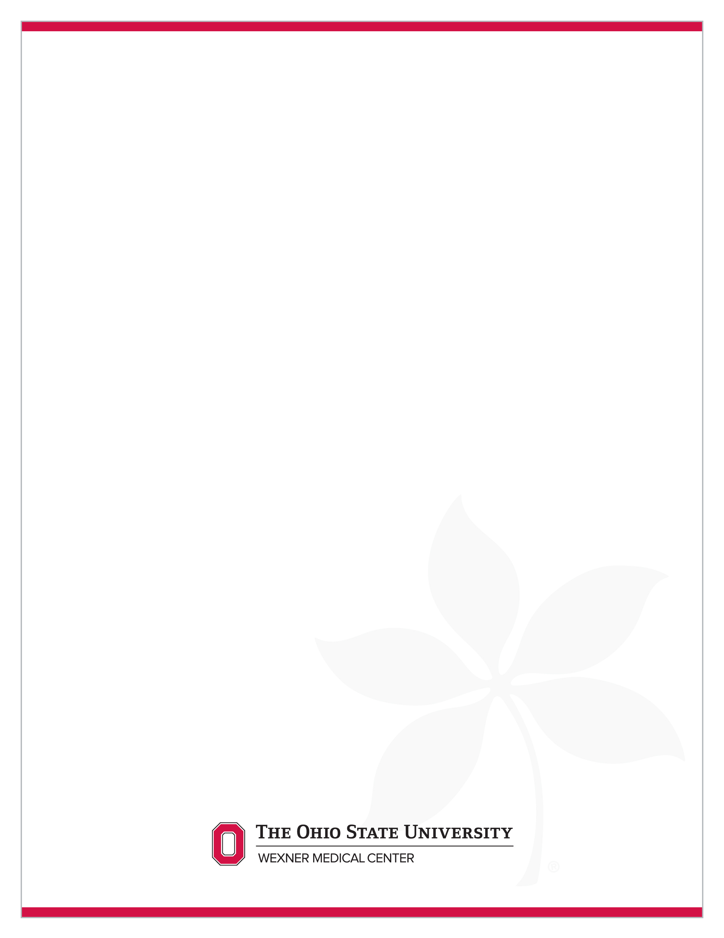

**Study Short Name Subject Initials/Subject#**

Questions or problems with the study please contact #### at #### or [####@osumc.edu](mailto:####@osumc.edu).

All visits occur at #### address.

Please still drink plenty of water, but no food, when you arrive fasting for labs.

|  |  |  |  |  |
| --- | --- | --- | --- | --- |
| **Visit** | **Visit Window** | **Scheduled Date** | **Time** | **Appt. Details** |
| 3-Week 16 | 06/07/19 -6/21/19 |  |  | 2-3 hours |
| 4-Week 32 |  |  |  | **FASTING VISIT** Hold Morning dose until after blood draw |
| 5-Week 48 |  |  |  |  |
| 6-Week 64 |  |  |  | **FASTING VISIT** Hold Morning dose until after blood draw |
| 7-Week 80 |  |  |  |  |
| 8-Week 96 |  |  |  | **FASTING VISIT** Hold Morning dose until after blood draw |
| 9-Follow-up |  |  |  |  |

**Study Medication Information:**

* Take capsules whole do not open or chew. Missed doses can be taken if it is more than 6 hours before the next scheduled dose. If less than skip the dose.
* Please call us if you are having problems with the medication. Do not reduce or increase the dose if having difficulty. Talk with Dr. XXXX first.
* Must keep all study medication supplies even when the bottles are empty. Will bring back kits and all unused medication to follow-up visits and be dispensed new kits.
* If you miss a dose(s) please document it.

**Other New medication or Changes**

* If you take any new medication or change existing medications I will need to know how long you took it, the name, dose, and the reason you took it.

THE OHIO STATE UNIVERSITY WEXNER MEDICAL CENTER