INSTRUCTIONS FOR INVESTIGATORS
LOG IN:
- Go to https://myccts.osu.edu/.
- Login with your OSU name.##.
- To request a service, you are asked to first enter information about the project.
- Complete required information on Create Project page and click Save.
- On the next window, choose CCTS Vouchers under Request a New Service.
- Choose “CCTS Core Voucher Award” from the drop down list, add any notes and click Create Service request.
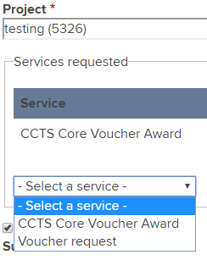
- When all services have been added to the “cart”, click Submit request(s)
- You will be taken to your Dashboard where all of your service requests for all of your projects are listed.
- To request services on the same project but from a different service provider such as Recruitment, click Request a new service.

You will receive an intake form from CCTS Voucher Staff. If you do not, contact cctsvoucher@osumc.edu

