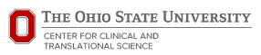
Promoting a Facebook Post as a Participant Recruitment Strategy
Background Information for the IRB and Submission Template for Approval
Currently, over a billion people use Facebook and Instagram every day to access a variety of content. Unfortunately, there is a lot of content on these social media platforms and information is not always delivered to the most valuable audience. It is possible to make it more likely that a certain audience sees a post about a research study by using the Facebook Ads system.
The Center for Clinical and Translational Science (CCTS) will utilize the Facebook Ad System as a participant recruitment strategy. The CCTS Facebook page will work with your team to develop a Facebook Ad and will host the ad on the CCTS page once it has been IRB approved. As part of the ad you’ll choose a target audience, a total budget, and the duration you want it to run.
There are several things you can do on Facebook Ads system:
- Having plenty of objective options.
- Choosing detailed placement options.
  - Facebook newsfeeds and side ads, Instagram feeds, Instagram stories, instant articles, messenger ads, and audience network ads. You can also choose if you’d like your campaign to be shown to mobile or desktop users only.
- Allowing for more targeting customization.
- Gaining more creative control.

There is a cost for this (charged by Facebook). The cost dedicated to this method can be minimal (as little as $5) or a team can decide to dedicate a significant amount to this method if it appears to be working. The research team can decide ahead of time how much of a budget they want to provide for this service. More information about the cost of Facebook ads on page 3.
We can work with you to determine characteristics of an audience (dependent upon the social media characteristics of the potential participants). Facebook will then attempt to display that post on the Facebook and Instagram newsfeeds of those that fit the demographics selected (such as age, location, interests, behaviors, etc). Neither the study team nor the CCTS staff members are aware of whose Facebook or Instagram newsfeeds this ad will appear. Users who are being “shown” the ad are not identified to those using this method. Only if the potential participant who sees the ad decides to follow up with the study team will the team know that person has seen the post.
We can also assist you with finding a suitable image for your ad.
To request a Facebook Targeted Marketing please complete the intake form found here: http://go.osu.edu/fbrequest

Here are examples of how a Facebook ad may appear. It does not display differently to users than a normal post on Facebook within their feed - even though they have been targeted based on their Facebook behaviors.
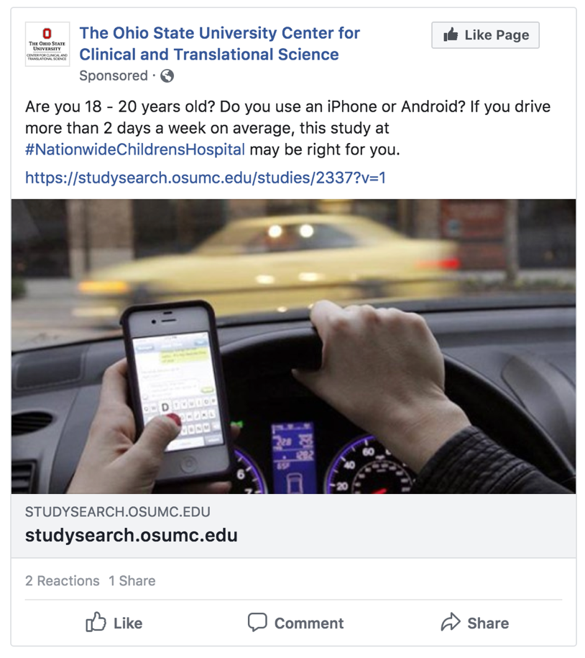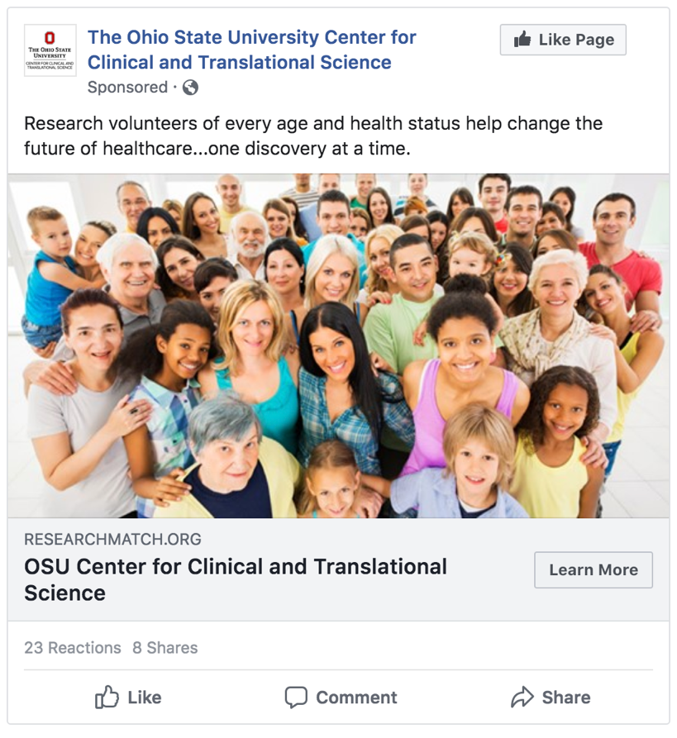
Below is the advertisement that will need to be submitted to the IRB for use of this recruitment strategy
- High Resolution Image (CCTS can assist with finding an appropriate image)
- Preferred size: 1200x628 px, in JPG or PNG format
- Cannot include more than 20% text on image (we prefer no text though).

Message/Text to be run with ad (character limits below):
Headline: 25 characters
Text: 215 Characters
Link Description: 30 characters

Targeting Criteria
Age Ranges:
Location (city, zip code, etc.):
Health Conditions:
Interest/Pages:
Desired Budget:
Timeframe for running Ad:
Call to Action (link to website, follow page, contact now, etc.):

How much do Facebook Ads cost?
You can run ads on Facebook, Instagram and Audience Network on any budget. Some people spend more on coffee each day than they do on their ad campaigns. The exact cost associated with your ad being shown to someone is determined in our ad auction. Learn how pricing works for our ads, and how to set a budget that works for you.

How much it costs to advertise on Facebook
You control your overall amount spent through your budget. You tell Facebook how much you want to spend on advertising. Then Facebook will try to get you as many results as possible for that amount.

What you get from Facebook ads
There are two primary things you get from a Facebook ad:

- The ability to reach a certain number and type of people.
- As many of the results you care about (as expressed by the type of boost/promotion you choose on your Page or the optimization event choice you make in ad set creation) as possible from those people.

Given the characteristics of your ad (including its budget, bid, and targeting), Facebook will estimate the number of people you can reach and results you can get before you actually order your ad. This can help you decide if you want to order the ad or not.

During and after your campaign, The CCTS will send you notifications about the performance of your ad. It is also helpful if you track the number of people you enroll as a result of the Facebook ad. In addition, we ask that you report metrics back to us. How do you do think the ad worked? Did you notice an increase in web visits, emails, phone calls, or study sign-ups? By providing us with this information, we are better able to plan for future ads regarding study recruitment.

Your Facebook Ad will require IRB approval once and you will submit a DocuSign form to the CCTS for the cost of your ad. The minimum for the request is $0 BUT we will only bill what is spent.

To begin the process please complete the following intake form http://go.osu.edu/fbrequest

Sarah Mann  Sr. Communications and Marketing Consultant  376 West Tenth Avenue, Suite 260  Columbus OH 43210  614-366-6211  Sarah.Mann@osumc.edu | Jeffrey Jessberger  Marketing & Communications Coordinator  376 West Tenth Avenue, Suite 260  Columbus OH 43210  614-293-4431  Jeffrey.Jessberger@osumc.edu
Mary Becker
Coordinator, Recruitment Services
376 West Tenth Avenue, Suite 260
Columbus OH 43210
614-293-4198
Mary.Becker@osumc.edu

