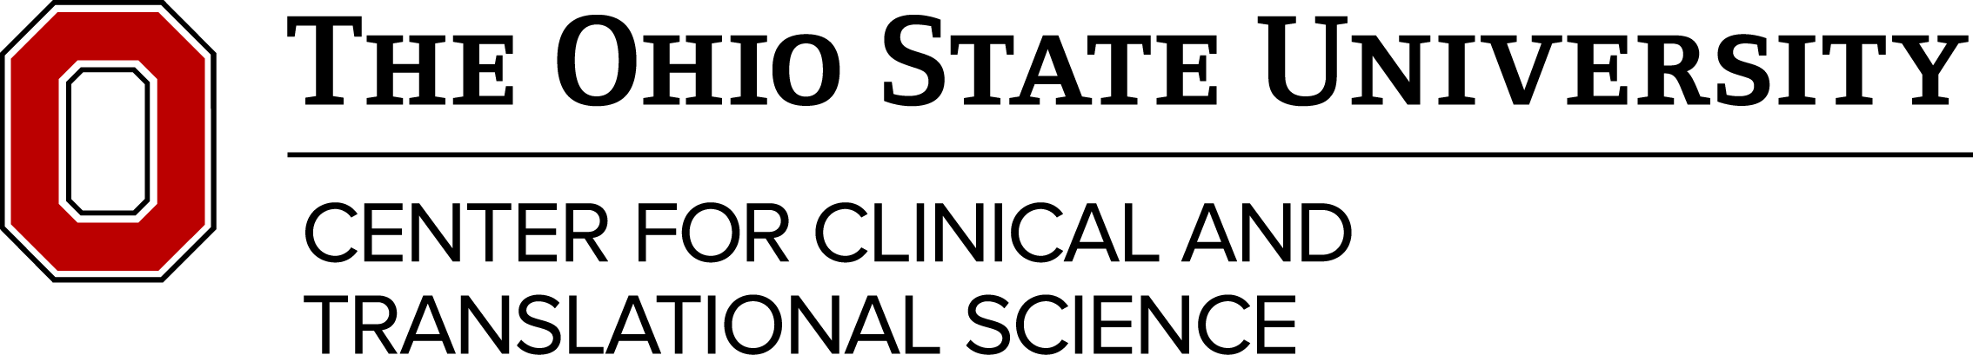

CTSA Grant Renewal Focus Group

Agenda
- Overview of CCTS (5-15 minutes)
- Sample Questions that may be discussed:
  - How might the CCTS better serve the research community needs in relational to clinical and translational science?
  - What additional services/assets might we offer the community? Are there ways to offer them differently? For example, online/on demand, research resources, etc.
  - What are the existing/emerging resources on campus that CCTS could better leverage? For example, DDI, IRF, Interdisciplinary Health Sciences Center, etc.
  - Are there programs/services that the CCTS might consider sunsetting or need to be refocused? Have some of our tried-and-true initiatives run their course? Have any of these programs been replaced by other campus units?

