Creating a New Study Record for ClinicalTrials.gov

Applicable clinical trials under 42 CFR 11 and NIH-funded clinical trials must be registered no later than 21 calendar days after the first human subject is enrolled. However, ICMJE requires that studies are registered prior to the first subject enrollment. Please refer to any relevant regulations for details.
Please note that a trial is considered registered once the responsible party releases the record to PRS for review.
- Log in to the ClinicalTrials.gov Protocol Registration and Results System (PRS) website. https://register.clinicaltrials.gov/
Use the organization name and username that you received when your account was generated. For non-cancer clinical trials, the organization will be OhioU. If you do not remember your login information, or if you need to reset your password, contact your administrator.
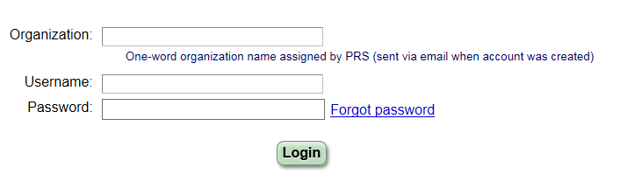
- Create a New Record under Quick Links
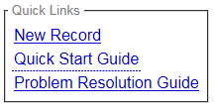
- Verify that you are responsible for registering the study.
- Enter the OSU IRB number as the Organization’s Unique Protocol ID (ex: 2017H0115) and fill in the rest of the information as it applies to your study.
- Continue filling in the information as it applies to your study. Please note that Secondary ID may be the grant/contract award number, registry identifier, EudraCT number, or other identifier.
- You can click Continue or Quit if you need to come back to a page and any information already entered will be saved.

- Oversight > Human Subject Protection Review, enter the information as follows:
Board Name: | Biomedical Sciences IRB
Board Affiliation: | The Ohio State University
Board Contact: | Sandra Meadows
Phone: | 614-688-8641
Email: | meadows.8@osu.edu
Address: | 1960 Kenny Road  Columbus, OH 43210

- Tips:
- The Help and Definitions links are unique to each page’s content and can be very helpful.
- For additional help, you can contact the site administrators by clicking on the Contact ClinicalTrials.gov PRS link in the upper right corner of the page. You can also contact the OSU administrators for help.
- Study Identification > Secondary ID: the grant/contract award number, registry identifier, EudraCT number, or other identifier.
- Study Status > Record Verification Date: This date refers to the current month and year. When updating a record, always update the Record Verification Date.
- Sponsor/Collaborators > Responsible Party should be listed as Principal Investigator or Sponsor-Investigator for any OSU-led studies. Please see the COM ClinicalTrials.gov SOP for more information on determining the responsible party.
- Preview: You can Preview how your record will look on the public site by clicking on Preview above the Protocol Section.
- Oversight: The information contained within the Oversight section is used to determine the registration and reporting requirements per 42 CFR 11. Please verify that this information is entered correctly and ask for help as needed.
- After completing the initial questions, you will be brought to the Protocol Section page. You can update information as needed by clicking Edit next to the desired section.
- Verify that your record is free from errors prior to completing.
ERROR messages indicate serious problems that must be addressed.
WARNING messages indicate items that are (or may be) required by FDAAA 801.
NOTE messages indicate potential problems that should be reviewed and corrected as needed.
- On the Record Summary page, add the PI to the Access List by clicking Edit and selecting his/her name if he/she is not the record owner. If the PI’s name is not listed, submit a request to your administrator to have an account created.
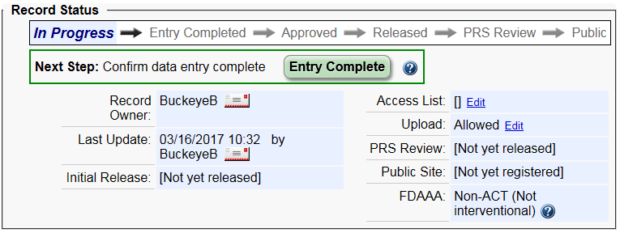
- Once the record is complete, click on Entry Complete. The record owner and Responsible Party will be sent an automated email to indicate that the record is complete and ready for approval and review.
If any changes need to be made after an entry is marked complete, click Reset to In-Progress above the Next Step box or simply edit the necessary section and it will automatically reset.
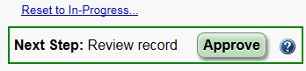
- The Responsible Party needs to log in to the system to review the record and approve the record by clicking the Approve button within the Next Step box.
- The Responsible Party then needs to release the record for PRS review by clicking the Release button within the Next Step box.
- Once a record is released, it will be sent to the ClinicalTrials.gov PRS quality assurance (QA) review prior to being assigned an NCT number and being published to the public site.
- If there are any comments from the PRS review, the record will be reset to In Progress and the Next Step box will be updated to Address Review Comments. Comments must be addressed no later than 15 calendar days after notification.
A link to the comments will be provided under the PRS Review and there will be a flag by any section(s) that has comments that need to be addressed.
- Once the record has been updated to address the QA comments, repeat steps 12-16 until the PRS review returns no comments.
- The record will be published to the public site and an NCT number will be generated.
- Notes for updating and maintaining records: Please see SOP 20 Attachment B for more details.
  - Each record must be verified at least once every 6 months for actively enrolling studies or 12 months for studies closed to enrollment, even if nothing has changed.
  - Records must be updated no later than 30 calendar days of change in enrollment status or any other significant changes to the protocol.
  - Device Product Not Approved or Cleared by U.S. FDA must be updated no later than 15 calendar days after a change in approval or clearance status has occurred.
  - Clinical trial results must be posted no later than 1 year after the primary completion date. Delayed results submission is allowed in some cases; please see 42 CFR 11 for more details.
  - Any errors must be addressed no later than 15 calendar days after notification for clinical trial registration information, or 25 calendar days for clinical trial results information.

